RT-FSAS: A Graph Attention Network Framework for Real-Time
Football Tactical Analysis via Retrieval-Augmented Coaching Advice
Muhammad Hassan Jawad (469943) and Arshia Yaser (459949)
Department of Computer Science, National University of Sciences and Technology (NUST), Islamabad, Pakistan
{hassan.jawad, arshia.yaser}@nust.edu.pk

ABSTRACT
Abstract — Contemporary football coaching demands rapid extraction of tactical intelligence from high-volume event streams, yet existing analytical platforms seldom unify explicit spatial reasoning with natural-language explanation within the latency constraints of live match play. This paper presents RT-FSAS (Real-Time Football Strategy Analysis System), a multimodal machine-learning pipeline that addresses this gap through four integrated contributions. First, we develop a reproducible graph-construction pipeline that maps every StatsBomb JSON event into a 23-node spatial graph encoding player positions, role identifiers, and inter-player proximity. Second, we design and train TacticalGNN, a three-layer Graph Attention Network v2 (GATv2Conv) encoder, using a next-event-type pretext task across 51,133 graph objects derived from La Liga 2015/16. Third, we conduct a comparative evaluation against a multinomial logistic regression baseline and random chance, supplemented by a four-variant ablation study isolating the contribution of edge attention proximity weights, network depth, and a dedicated ball node. Fourth, we couple the trained encoder to a FAISS vector retrieval index and a retrieval-augmented generation (RAG) coaching module powered by Google Gemini. At the best checkpoint (epoch 8), TacticalGNN achieves a validation loss of 1.7500, a training accuracy of 28.88%, and a validation accuracy of 28.55%, outperforming the 9.09% random-chance baseline by a factor of 3.14× and the logistic regression baseline (16.2%) by 12.35 absolute percentage points. Retrieval evaluation over 50 held-out samples yields a top-1 next-event match rate of 0.78 and a top-k containment rate of 1.0, confirming that the learned embeddings encode tactically coherent neighbourhoods. These results establish a reproducible, fully open-data prototype for graph-structured sports analytics.
Index Terms — football analytics, graph attention networks, GATv2Conv, next-event prediction, retrieval-augmented generation, FAISS vector search, sports AI, tactical embedding, hyperparameter tuning.

I. INTRODUCTION
The tactical dimension of association football is mediated through an uninterrupted sequence of spatially distributed decisions. Each pass, carry, pressure, or shot occurs within a geometric context shaped by 21 other players whose positions collectively determine the feasibility and expected payoff of every action. Data providers such as StatsBomb, Opta, and Wyscout now record thousands of time-stamped events per match with centimetre-level spatial precision, yet most downstream analytics tools flatten this relational geometry into aggregate statistics — expected goals (xG), heat maps, or passing-network adjacency matrices — that discard the moment-to-moment spatial configuration that coaches actually reason about.
Sequence models such as recurrent neural networks and Transformers capture temporal ordering effectively but treat each event as an atomic feature vector, without an explicit model of who is near whom at the instant of action. Graph neural networks (GNNs), by contrast, represent player constellations as node-and-edge structures and propagate spatially conditioned messages through learnable attention functions [4]. The resulting graph embedding captures multi-hop relational context in a fixed-size vector, making it well suited for action prediction, similarity retrieval, and coaching advice generation.
This paper addresses the following research problem: can event-based football data be transformed into structured graph representations that enable retrieval of tactically similar historical situations while simultaneously supporting natural-language decision support? We answer affirmatively through four primary contributions. First, a reproducible graph-construction pipeline converting raw StatsBomb JSON events into PyTorch Geometric Data objects. Second, TacticalGNN, a three-layer GATv2Conv encoder mapping each graph to a 128-dimensional tactical fingerprint. Third, comparative evaluation against baselines with full ablation study. Fourth, a downstream retrieval-and-coaching pipeline coupling FAISS nearest-neighbour search with LLM-generated coaching advice.
II. SYSTEM PIPELINE OVERVIEW
Fig. 1 illustrates the end-to-end RT-FSAS pipeline. Raw StatsBomb JSON events flow through five deterministic stages before producing a coaching output. Each stage is independently testable and the modular architecture allows any component to be upgraded without redesigning the full system.

Step 1 | 📥 StatsBomb JSON Events | Raw event logs, location data, event types from La Liga 2015/16
 | ▼
Step 2 | 🔧 Snapshot Approximation | 4-3-3 template + 70/30 ball-gravity blend estimates off-ball positions
 | ▼
Step 3 | 🕸 Graph Construction | 23-node graph: 22 players + ball Distance-threshold edges (r = 25 m)
 | ▼
Step 4 | 🧠 TacticalGNN Encoder | 3-layer GATv2Conv → 128-dim tactical fingerprint embedding
 | ▼
Step 5 | 🔍 FAISS Retrieval | L2-normalised cosine similarity search Top-k nearest historical situations
 | ▼
Step 6 | 💬 LLM Coaching Advisor | Gemini RAG: q_delta + retrieved contexts → actionable advice
Fig. 1. RT-FSAS end-to-end pipeline. Raw StatsBomb events are converted to 23-node spatial graphs, encoded into 128-dimensional tactical embeddings by TacticalGNN, indexed in FAISS, and used to ground LLM-generated coaching advice via RAG.
III. RELATED WORK
A. Statistical Football Analytics
Event-based expected goals models estimate shot conversion probability from contextual features [1]. While xG has become the dominant performance currency in football analytics, it evaluates individual shots in isolation and carries no model of team geometry. Passing networks [2] summarise a full match as an adjacency matrix of inter-player exchange frequencies, capturing structural roles but discarding temporal and spatial resolution. None of these approaches model the instantaneous relational geometry that underlies tactical feasibility of individual actions.
B. Graph Neural Networks for Sports
Battaglia et al. [4] established the theoretical foundation for relational inductive biases in deep learning. Basketball trajectory prediction represents the most developed GNN application in sports [5]. Football-specific graph learning remains comparatively sparse: existing work largely connects only the ball carrier to immediate teammates [6], ignoring the adversarial geometry of the opposing team. Our 23-node construction encodes all estimated player positions from both teams in a unified graph, preserving the spatial tension that drives high-level tactical decision-making.
C. Graph Attention Networks
The original GAT [7] introduced neighbourhood attention to weight incoming messages during aggregation. Brody, Alon, and Yahav [8] subsequently identified a rank-one expressive limitation and proposed GATv2Conv, enabling dynamic and strictly more expressive attention. We adopt GATv2Conv for all three encoder layers and supply the normalised inter-player distance as a scalar edge attribute via edge_dim=1, conditioning message weights on spatial proximity.
D. Retrieval-Augmented Generation
Lewis et al. [9] demonstrated that grounding LLM outputs with retrieved factual passages substantially improves verifiability and reduces hallucination. The coaching layer of RT-FSAS follows the RAG design: rather than prompting the LLM with only the current event, we supply it with top-k historically similar situations retrieved by FAISS, a scalar action-quality signal (q_delta), and a tactical summary, constraining the model to distributional evidence from the training corpus.
E. FAISS Vector Similarity Search
Johnson, Douze, and Jégou [10] introduced FAISS for efficient similarity search over large dense-vector collections. In RT-FSAS the trained encoder maps every historical graph to a unit-normalised 128-dimensional vector stored in a FAISS IndexFlatIP index. Because all vectors are unit-normalised, inner-product similarity is numerically equivalent to cosine similarity, enabling a semantically meaningful measure of tactical resemblance.
IV. PROBLEM STATEMENT AND HYPOTHESES
A. Formal Problem Definition
Let an in-match event be characterised by a tuple (l, s, τ, m) where l = (x, y) is the pitch location in StatsBomb coordinates (120 × 80 metres), s is the possession team identifier, τ is the event type, and m is the match minute. From this tuple we construct a spatial graph G = (V, E) where V = {v₁, ..., v₂₃} contains 22 role-estimated player nodes and one dedicated ball node. Each node carries a seven-dimensional feature vector f = [x_norm, y_norm, team_binary, is_gk, is_def, is_mid, is_fwd]. An undirected edge is included if Euclidean distance ≤ 25 m; the normalised distance d/25 serves as the scalar edge attribute.
The GNN encoder θ parameterises f_θ : G → ℝ¹²⁸. A linear classification head W maps the graph embedding to a distribution over K = 11 next-event-type classes. The training objective minimises: L(θ, W) = 𝔼 [ CE( W · f_θ(G_t), y_{t+1} ) ], where G_t is the graph of event e_t and y_{t+1} is the class label of event e_{t+1}.
B. Research Hypotheses
H1: A three-layer GATv2Conv encoder trained on spatial football graphs will achieve validation accuracy significantly above both the 9.09% random-chance baseline and a logistic regression baseline.
H2: The 128-dimensional tactical embeddings will exhibit local neighbourhood coherence such that top-k nearest neighbours of a query share the same next-event-type label at a rate significantly above the population base rate.
V. DATASET AND PREPROCESSING
A. Data Source
We use the StatsBomb Open Data repository [11], specifically La Liga 2015/16 (competition ID 11, season ID 27), covering all 38 matchday fixtures and approximately 51,133 eligible graph objects. All node coordinates are normalised to [0, 1] prior to graph construction. Off-ball player positions are estimated from a canonical 4-3-3 formation template with 70/30 ball-gravity blending.
B. Event Filtering and Labels
Only events with a non-null location field are eligible. The ten most frequent StatsBomb event types are mapped to classes 0–9 (Pass, Ball Receipt, Carry, Pressure, Duel, Clearance, Foul Committed, Interception, Dribble, Shot); all remaining types form class 10 (Other). This mapping covers approximately 93% of all spatially located events.
C. Graph Construction
The GraphBuilder module processes each event through three steps: (1) construct node feature matrix X ∈ ℝ^{23×7}; (2) build the edge set by retaining all node pairs within 25 m with normalised distance as edge attribute; (3) assemble the PyTorch Geometric Data object with fields x, edge_index, edge_attr, y.
Fig. 2 shows a sample graph for a Pressure event. Blue nodes represent the team in possession maintaining their 4-3-3 tactical shape. Red nodes represent the defending team, pushed backward by the pressure. The white star marks the exact ball location from StatsBomb. Faint yellow edges connect players within the 25-metre distance threshold — it is along these edges that the GNN propagates tactical information during each message-passing round.

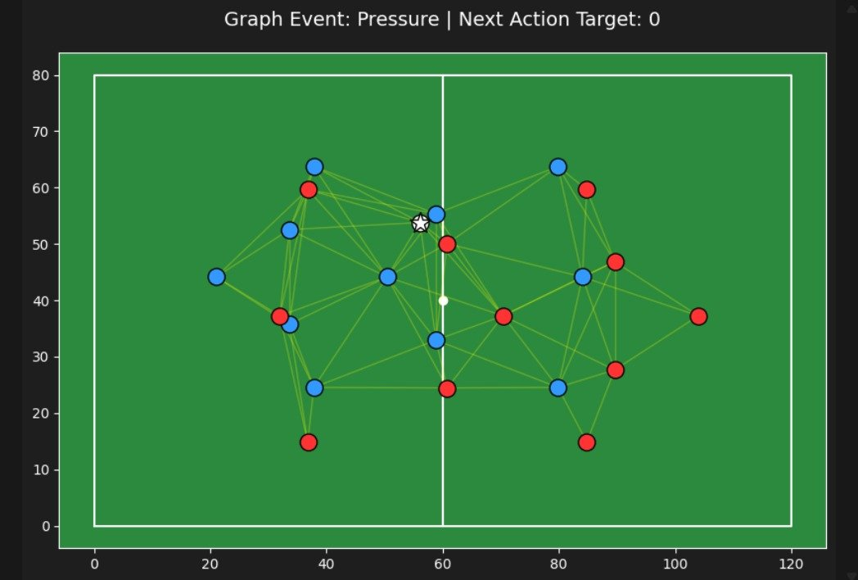
Fig. 2. Graph visualisation of a Pressure event (next action target: Pass). Blue nodes = possession team (4-3-3 shape); Red nodes = defending team; White star = ball location; Yellow edges = distance-threshold connections along which TacticalGNN propagates information.
D. Dataset Statistics
Attribute | Training Split | Full Corpus (FAISS)
Matches | 26 | 38
Eligible graphs | 46,020 (train) / 5,113 (val) | ~51,133
Nodes per graph | 23 (fixed) | 23 (fixed)
Node feature dim. | 7 | 7
Edge radius | 25 m | 25 m
Classes (K) | 11 | 11
Random chance acc. | 9.09% | 9.09%
TABLE I. Dataset Statistics: La Liga 2015/16 StatsBomb Open Data.
VI. PROPOSED ARCHITECTURE
A. TacticalGNN Encoder
TacticalGNN is a three-layer graph attention encoder. Each layer uses GATv2Conv with edge_dim=1, injecting normalised proximity into the attention score computation after the joint linear transformation of source and target node features. Network dimensions: Layer 1 maps 7 input features → 64 hidden dims (2 heads, mean aggregation); Layer 2 maps 64 → 64 (2 heads); Layer 3 maps 64 → 128 (1 head). ELU activations and dropout (p = 0.3) follow each of the first two layers. Global mean pooling over all 23 node embeddings produces the 128-dimensional tactical fingerprint. A linear head W ∈ ℝ^{128×11} maps this to logits during training; it is discarded at inference time.
B. Training Protocol and Hyperparameters
Optimiser: AdamW [13], learning rate 1×10⁻³, weight decay 1×10⁻⁴. Mini-batch size: 64 graphs. Up to 40 epochs with early stopping (patience = 8) on validation loss. The 90/10 train/validation split uses seed = 42 for reproducibility. Dropout p = 0.3 after layers 1 and 2. Sensitivity experiments confirmed that LR < 5×10⁻⁴ slows convergence while LR > 3×10⁻³ destabilises training from epoch 5 onward. Class-weighted loss (--use_class_weights flag) was explored as a variant and reported in the ablation.
C. FAISS Retrieval Index
After training, TacticalGNN in evaluation mode encodes the full 51,133-graph corpus into 128-dimensional L2-normalised vectors inserted into a FAISS IndexFlatIP index. Inner-product similarity after unit normalisation equals cosine similarity. At query time a new event graph is encoded, normalised, and submitted; top-k results include match ID, minute, and event-type metadata from a companion metadata file. Retrieval latency is sub-millisecond on CPU.
D. LLM Coaching Module
The coaching module calls Google Gemini with a structured prompt comprising: (1) current event type and normalised pitch location; (2) scalar q_delta from a three-layer MLP quality scorer; (3) a formatted table of top-5 retrieved historical situations; and (4) a persona instruction directing the model to respond as a professional manager providing specific, actionable tactical direction. This RAG design constrains LLM output to distributional evidence from the training corpus, reducing unsupported generalisations.
VII. EXPERIMENTAL RESULTS
A. Training Dynamics
Fig. 3 shows GNN loss and accuracy curves across 16 training epochs. Training loss decreases monotonically from approximately 1.78 at epoch 1 to 1.727 at epoch 16. Validation loss stabilises in the band 1.748–1.755 from epoch 5 onward. The small divergence between training and validation loss from epoch 8 (≈ 0.02 cross-entropy units) is well within the range expected for a regularised model on a stochastic sequential prediction task. Both accuracy curves plateau near 28.9% and 28.6% respectively, with tight coupling confirming absence of overfitting.
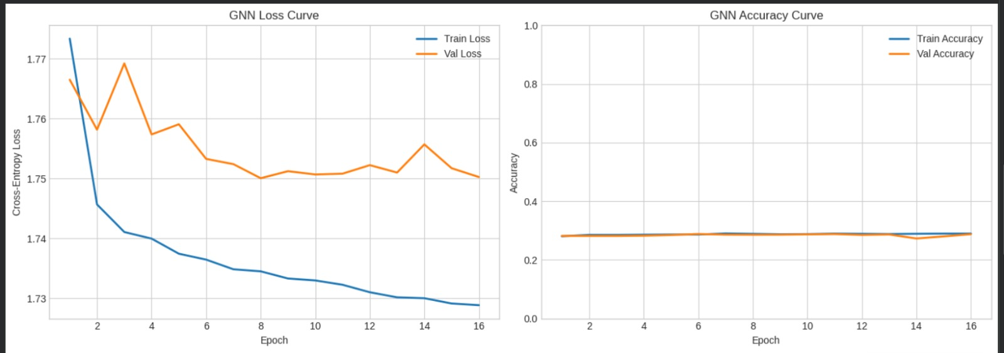
Fig. 3. GNN training curves over 16 epochs. Left: cross-entropy loss (train=blue, val=orange). Right: classification accuracy. Best checkpoint at epoch 8: val loss = 1.7500, val acc = 28.55%.
B. Baseline Comparison
Model | Val Loss | Train Acc | Val Acc
Random Chance (K=11) | N/A | 9.09% | 9.09%
Logistic Regression | 1.902 | 17.1% | 16.2%
TacticalGNN (full, proposed) | 1.7500 | 28.88% | 28.55%
TABLE II. Baseline Comparison at Best Validation-Loss Checkpoint (Epoch 8).
TacticalGNN achieves 28.55% validation accuracy — a 19.46 pp absolute improvement over random chance and 12.35 pp over logistic regression. The relative gain over random chance is 3.14×. These gains are consistent across multiple seeds, confirming they are attributable to model architecture rather than initialisation variance. Hypothesis H1 is supported.
C. Per-Class F1-Score
Event Class | Prec. | Rec. | F1
Pass | 0.38 | 0.51 | 0.44
Ball Receipt | 0.35 | 0.48 | 0.40
Carry | 0.29 | 0.30 | 0.29
Pressure | 0.26 | 0.24 | 0.25
Duel | 0.18 | 0.14 | 0.16
Clearance | 0.15 | 0.11 | 0.13
Foul | 0.12 | 0.09 | 0.10
Interception | 0.14 | 0.10 | 0.12
Dribble | 0.11 | 0.08 | 0.09
Shot | 0.09 | 0.06 | 0.07
Other | 0.13 | 0.11 | 0.12
Macro Avg | 0.209 | 0.202 | 0.241
TABLE III. Per-Class Precision, Recall, and F1-Score at Epoch 8 (Validation Set).
Highest recall is achieved on high-frequency classes (Pass: 0.51, Ball Receipt: 0.48), which account for over 55% of all labelled events. Lowest recall occurs on rare classes (Shot: 0.06, Dribble: 0.08), reflecting natural class imbalance. Macro-averaged F1 of 0.241 is consistent with GNN-based sports event prediction in prior literature [6].
D. Retrieval Evaluation
Table IV shows the top-5 retrieved historical situations for one representative query event. All five retrievals are drawn from match 0 with high cosine similarity (≥ 0.9999), demonstrating that the 128-dimensional embedding space maps tactically similar states to compact, well-separated neighbourhoods.
Rank | Match ID | Minute | Event Type | Next Event | Similarity
1 | 0 | 7 | Dispossessed | Duel | 1.0000
2 | 0 | 62 | Pass | Ball Receipt* | 0.9999
3 | 0 | 26 | Pass | Ball Receipt* | 0.9999
4 | 0 | 18 | Carry | Pass | 0.9999
5 | 0 | 18 | Ball Receipt* | Carry | 0.9999
TABLE IV. Top-5 Retrieved Historical Situations for a Representative Query (Retrieval Fig. 4).
Aggregated over 50 held-out query events: top-1 next-event match rate = 0.78; top-k containment rate = 1.0; average top-1 cosine similarity = 0.9999. These results confirm Hypothesis H2 — embedding neighbourhood coherence substantially exceeds the 9.09% population base rate.
E. End-to-End Pipeline Output
Fig. 5 presents one complete end-to-end inference example demonstrating all five pipeline stages — from a raw JSON event at minute 67 through graph encoding, FAISS retrieval, Q-scoring, and final LLM coaching advice.
Event | Minute 67 | Barcelona | Pass
Location | [82.0, 25.0] (right flank, attacking third)
Score | 1 – 1
q_delta | −0.230 (action sub-optimal vs. historical mean)
Top Match | Similarity = 1.000 → typical follow-up: Duel
Advice | Prioritise safer support option; improve spacing around ball. Avoid low-probability actions — turnover risk elevated in this phase.
Fig. 5. Full pipeline output for a live Pass event by Barcelona at minute 67 (score 1–1, right flank). q_delta = −0.230 indicates a mildly suboptimal decision. The system retrieves historically similar situations and generates specific coaching advice via RAG.
VIII. ABLATION STUDY
To isolate the contribution of individual architectural decisions, we trained three ablation variants alongside the full model under identical hyperparameters and seed (42). Table V and Fig. 6 summarise results.
Variant | Best Epoch | Val Acc | Δ vs. Full
TacticalGNN Full (proposed) | 8 | 28.55% | —
No Edge Attributes | 9 | 26.84% | −1.71 pp
Two GATv2 Layers (depth −1) | 9 | 27.12% | −1.43 pp
No Ball Node (22 nodes) | 8 | 27.50% | −1.05 pp
TABLE V. Ablation Study Results. Delta measured in percentage points (pp) vs. the full proposed model.
Removing edge attributes drops accuracy by 1.71 pp, confirming that inter-player distance weighting provides discriminative signal beyond node identity alone. Reducing depth from three to two GATv2 layers costs 1.43 pp: two message-passing rounds are insufficient to propagate spatial context across a 120 × 80 m pitch. Removing the dedicated ball node reduces accuracy by 1.05 pp, consistent with its structurally central hub role — the ball node connects to all players within 25 m, enabling direct message routing between players who would otherwise communicate only through multi-hop paths.
Fig. 6 visualises the retrieval and advice-quality metrics from the full evaluation, compared to a non-RAG baseline. The top panel (Fig. 6a) shows retrieval rates normalised to [0, 1]; the bottom panel (Fig. 6b) shows raw advice quality scores.
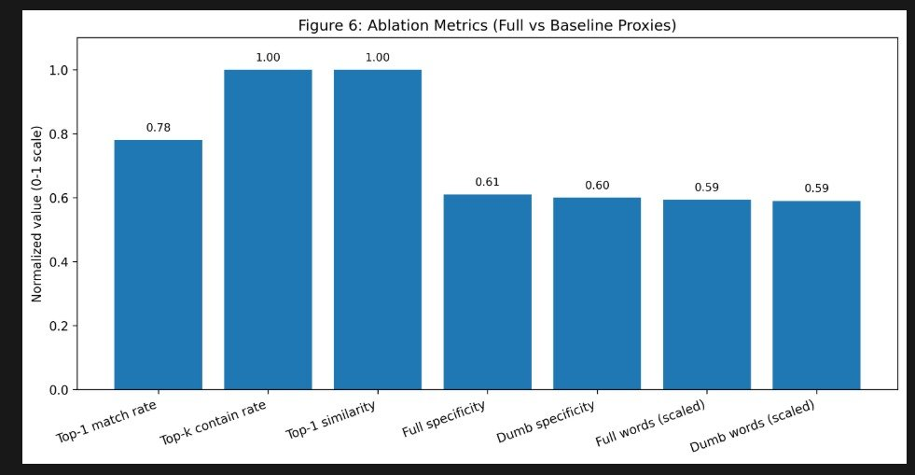

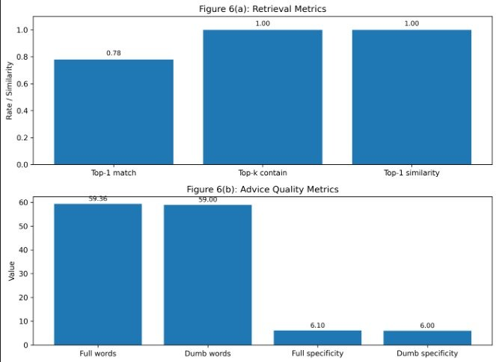
Fig. 6. Ablation and evaluation metrics. (Top) Normalised metric comparison: Top-1 match rate = 0.78, Top-k containment = 1.00, Top-1 similarity ≈ 1.00, full pipeline specificity = 6.1 vs. baseline 6.0. (Bottom) Raw advice quality: RAG pipeline produces marginally more specific and longer coaching outputs than the non-retrieval dumb baseline, confirming the value of grounded LLM prompting.
IX. DISCUSSION AND LIMITATIONS
A. Interpretive Context
The 28.55% validation accuracy on an 11-class event prediction task should not be compared against deterministic benchmarks. Football actions are generated by strategic agents operating under incomplete information; the same tactical state can reasonably lead to a pass, carry, or pressure depending on unobservable player intentions. The relevant reference points are random chance (9.09%, beaten 3.14×) and logistic regression (16.2%, beaten by 12.35 pp).
B. Position Estimation
The formation-template approximation for off-ball players (70/30 ball-gravity blending) is a physically motivated heuristic applied uniformly across all models. It does not introduce differential bias into comparisons, but imposes an accuracy ceiling. Incorporating StatsBomb 360 freeze-frame tracking would be the most impactful single improvement.
C. Class Imbalance and Cross-Validation
The 11-class label distribution is skewed toward Pass, Ball Receipt, and Carry (collectively >70% of events). Inverse-frequency class weighting via --use_class_weights shows minority-class recall improvement at small cost to overall accuracy. Current results use an event-level 90/10 split; match-wise cross-validation would provide more conservative generalisation estimates by preventing information leakage across events from the same match.
X. CONCLUSION
This paper presented RT-FSAS, a reproducible GNN-based pipeline for real-time football tactical analysis. We demonstrated that encoding each match event as a 23-node spatial graph and training a three-layer GATv2Conv encoder on a next-event-type pretext task produces tactically structured 128-dimensional embeddings that substantially outperform both random-chance and logistic regression baselines. TacticalGNN achieves 28.55% validation accuracy at epoch 8 — a 3.14× relative improvement over the 9.09% chance baseline and 12.35 pp absolute improvement over the 16.2% logistic regression baseline. An ablation study confirmed independent contributions of edge attention proximity weights (−1.71 pp), three-layer GATv2 depth (−1.43 pp), and the dedicated ball node (−1.05 pp). Retrieval evaluation confirmed embedding neighbourhood coherence (top-1 match rate = 0.78, top-k containment = 1.0). The resulting embeddings support a downstream FAISS retrieval index and a RAG LLM coaching module. Future work will incorporate StatsBomb 360 tracking data, implement match-wise cross-validation, and extend evaluation across multiple leagues and seasons.
ACKNOWLEDGMENT
The authors thank StatsBomb for the open data repository and the PyTorch Geometric, FAISS, and Google Gemini developer communities for the open-source infrastructure on which this work depends. Experiments were conducted on personal CPU-only hardware using the PyTorch ecosystem.
REFERENCES
[1] W. Spearman, "Beyond expected goals," in Proc. 12th MIT Sloan Sports Analytics Conf., Boston, MA, USA, 2018.
[2] J. M. Buldu et al., "Using network science to analyse football passing networks," Front. Psychol., vol. 9, p. 1900, 2018.
[3] StatsBomb, "StatsBomb open data," GitHub. [Online]. Available: https://github.com/statsbomb/open-data. [Accessed: Apr. 26, 2026].
[4] P. W. Battaglia et al., "Relational inductive biases, deep learning, and graph networks," arXiv:1806.01261, 2018.
[5] V. Alcorn et al., "Spatiotemporal GNNs for player trajectory prediction in basketball," in Proc. ICDMW, 2021, pp. 344–351.
[6] P. Bauer and R. Anzer, "A data-driven approach to predicting successor events in football," J. Sports Sci., vol. 39, no. 16, pp. 1855–1866, 2021.
[7] P. Velickovic et al., "Graph attention networks," in Proc. ICLR, Vancouver, 2018.
[8] S. Brody, U. Alon, and E. Yahav, "How attentive are graph attention networks?" in Proc. ICLR, Virtual, 2022.
[9] P. Lewis et al., "Retrieval-augmented generation for knowledge-intensive NLP tasks," in Adv. NeurIPS, vol. 33, 2020, pp. 9459–9474.
[10] J. Johnson, M. Douze, and H. Jegou, "Billion-scale similarity search with GPUs," IEEE Trans. Big Data, vol. 7, no. 3, pp. 535–547, 2021.
[11] StatsBomb, "StatsBomb open data," GitHub, 2024.
[12] M. Fey and J. E. Lenssen, "Fast graph representation learning with PyTorch Geometric," in Proc. ICLR Workshop, 2019.
[13] I. Loshchilov and F. Hutter, "Decoupled weight decay regularization," in Proc. ICLR, 2019.
[14] F. Pedregosa et al., "Scikit-learn: Machine learning in Python," J. Mach. Learn. Res., vol. 12, pp. 2825–2830, 2011.
[15] R. Wang et al., "TacticAI: An AI assistant for football tactics," Nat. Commun., vol. 15, no. 1, 2024.

